Cilj sustava
Napraviti IoT/SCADA demo platformu koja:
- simulira trafostanice u Čakovcu
- generira MQTT podatke senzora
- sprema podatke u CrateDB
- koristi EMQX kao MQTT broker
- koristi Locust za simulaciju senzora
- ima realtime dashboard u Vue.js
- prikazuje geo lokacije trafostanica na mapi
- prikazuje električne senzore i alarme

Tehnologije

Backend / IoT
Komponenta | Tehnologija
MQTT broker | EMQX
Simulator | Locust
Database | CrateDB
API backend | FastAPI
Realtime | WebSocket

Frontend
Komponenta | Tehnologija
Frontend | Vue 3
Build | Vite
Mapa | Leaflet
State | Pinia
Grafovi | ECharts

Što će simulirati trafostanice

Električni senzori
- napon
- struja
- frekvencija
- aktivna snaga
- jalova snaga
- harmonici

Temperatura
- temperatura ulja
- temperatura namota
- temperatura sabirnica
- ambijentalna temperatura

Ulje i plinovi
- razina ulja
- tlak ulja
- vlaga
- vodik
- metan
- acetilen

Dummy trafostanice Čakovec
ID | Naziv | Lokacija
TS-001 | TS Centar | Čakovec centar
TS-002 | TS Jug | Jug
TS-003 | TS Sjever | Sjever
TS-004 | TS Istok | Istok
TS-005 | TS Zapad | Zapad

Arhitektura
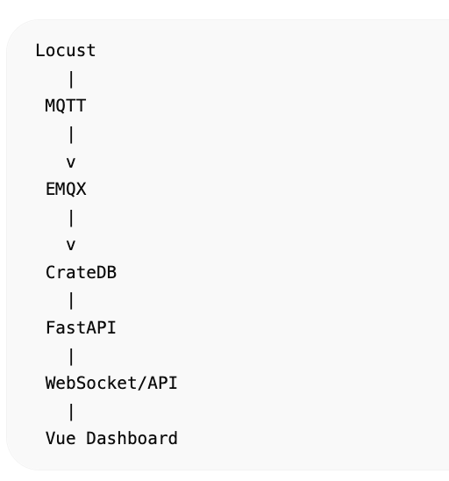

Projekt struktura
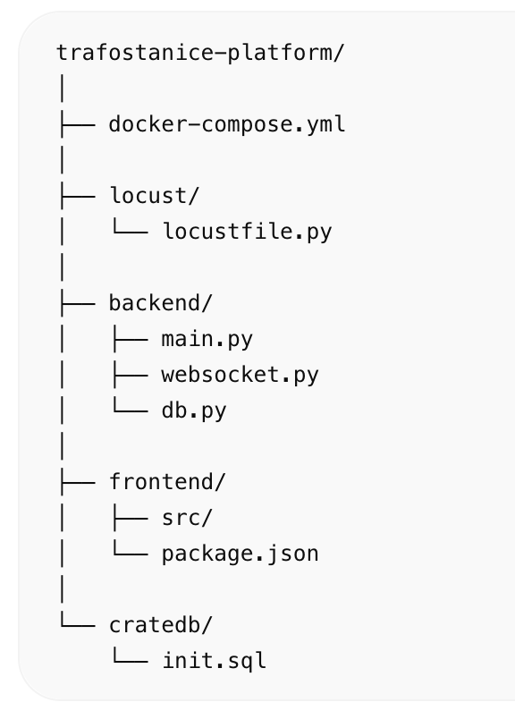

Prvi korak
Prvo dižemo infrastrukturu:
- CrateDB
- EMQX
- Backend
- Vue frontend
- Locust simulator

Docker compose
Početni docker-compose.yml
version: '3.9'  services:  cratedb:  image: crate:latest  container_name: cratedb  ports:  - "4200:4200"  - "5432:5432"  command: >  crate  -Ccluster.name=trafostanice  -Cnode.name=node1  -Cauth.host_based.enabled=false  emqx:  image: emqx/emqx:latest  container_name: emqx  ports:  - "1883:1883"  - "18083:18083"  backend:  build: ./backend  container_name: backend  ports:  - "8000:8000"  depends_on:  - cratedb  - emqx  frontend:  build: ./frontend  container_name: frontend  ports:  - "5173:5173"  depends_on:  - backend | 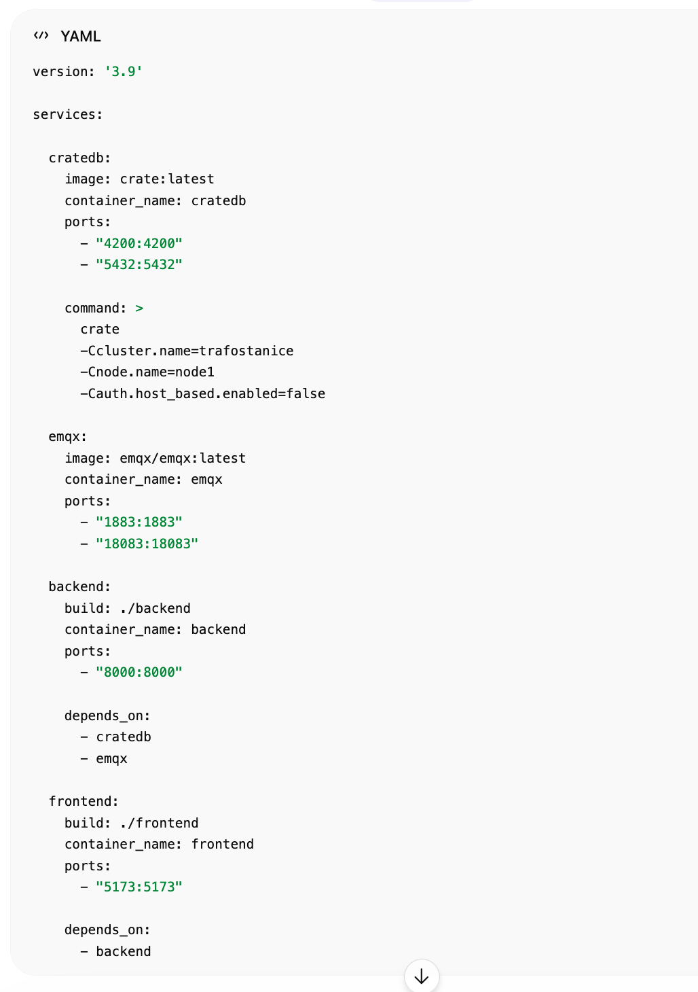

CrateDB tablica
cratedb/init.sql
CREATE TABLE trafostanice_sensors (  timestamp TIMESTAMP,  station_id TEXT,  station_name TEXT,  location GEO_POINT,  electrical OBJECT(DYNAMIC) AS (  voltage_kv DOUBLE,  current_a DOUBLE,  frequency_hz DOUBLE,  active_power_kw DOUBLE,  reactive_power_kvar DOUBLE,  harmonics_thd DOUBLE  ),  thermal OBJECT(DYNAMIC) AS (  oil_temp_c DOUBLE,  winding_temp_c DOUBLE,  busbar_temp_c DOUBLE,  ambient_temp_c DOUBLE  ),  oil_gas OBJECT(DYNAMIC) AS (  oil_level_percent DOUBLE,  oil_pressure_bar DOUBLE,  humidity_ppm DOUBLE,  hydrogen_ppm DOUBLE,  methane_ppm DOUBLE,  acetylene_ppm DOUBLE  )  ); | 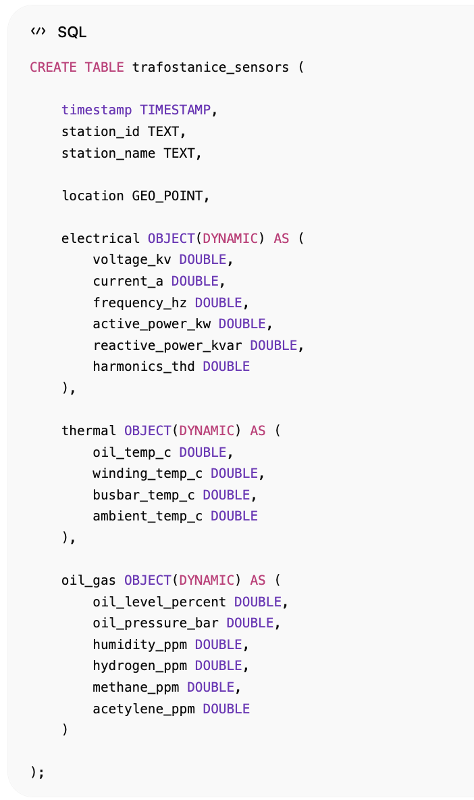

MQTT payload
Primjer poruke:
{  "timestamp": "2026-05-16T12:00:00Z",  "station_id": "TS-001",  "station_name": "TS Centar",  "location": [16.4339, 46.3844],  "electrical": {  "voltage_kv": 10.2,  "current_a": 240,  "frequency_hz": 50.01,  "active_power_kw": 1800,  "reactive_power_kvar": 210,  "harmonics_thd": 2.1  },  "thermal": {  "oil_temp_c": 64,  "winding_temp_c": 72,  "busbar_temp_c": 43,  "ambient_temp_c": 20  },  "oil_gas": {  "oil_level_percent": 88,  "oil_pressure_bar": 1.3,  "humidity_ppm": 18,  "hydrogen_ppm": 10,  "methane_ppm": 4,  "acetylene_ppm": 0  }  } | 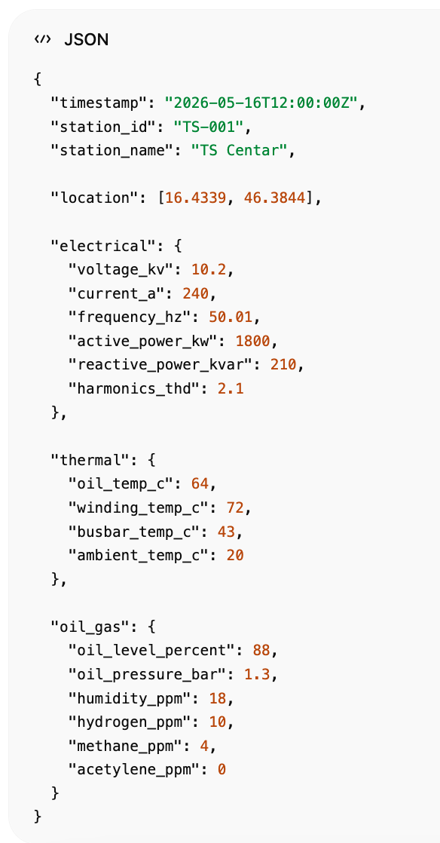

Dummy trafostanice — Čakovec

Primjer dummy geo lokacija
[  {  "id": "TS-001",  "name": "TS Jug",  "lat": 46.3812,  "lon": 16.4321  },  {  "id": "TS-002",  "name": "TS Centar",  "lat": 46.3851,  "lon": 16.4358  },  {  "id": "TS-003",  "name": "TS Sjever",  "lat": 46.3925,  "lon": 16.4290  },  {  "id": "TS-004",  "name": "TS Istok",  "lat": 46.3878,  "lon": 16.4450  },  {  "id": "TS-005",  "name": "TS Zapad",  "lat": 46.3840,  "lon": 16.4200  }  ] | 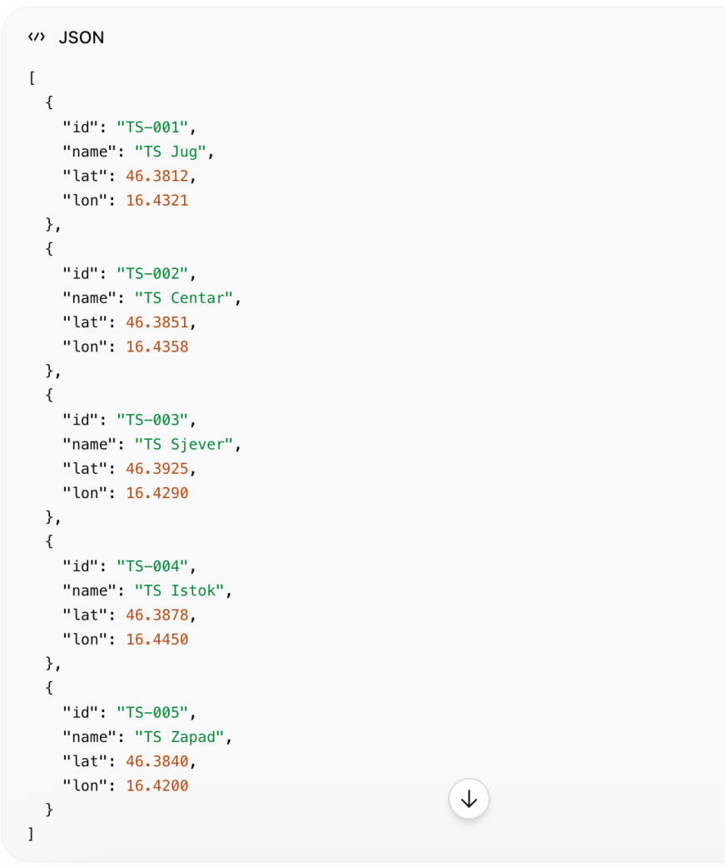

Senzori koje simuliraš

Električni senzori
{  "voltage_kv": 10.2,  "current_a": 245,  "frequency_hz": 49.98,  "active_power_kw": 1850,  "reactive_power_kvar": 220,  "harmonics_thd": 2.1  } | 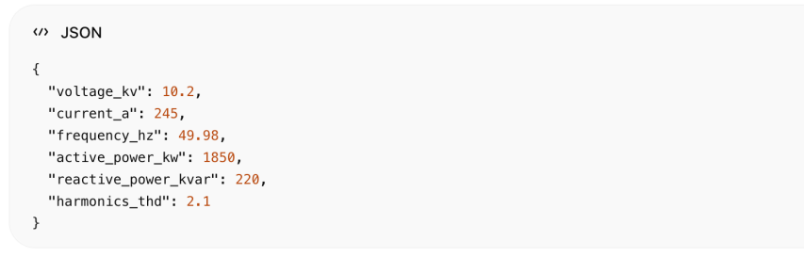

Temperatura
{  "oil_temp_c": 63,  "winding_temp_c": 71,  "busbar_temp_c": 45,  "ambient_temp_c": 18  } | 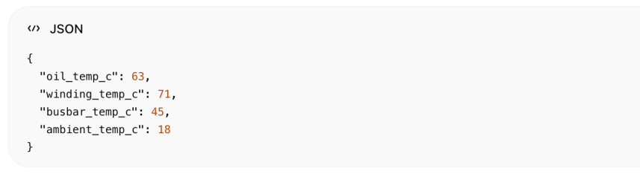

Ulje i plinovi
{  "oil_level_percent": 87,  "oil_pressure_bar": 1.2,  "humidity_ppm": 22,  "hydrogen_ppm": 15,  "methane_ppm": 4,  "acetylene_ppm": 0  } | 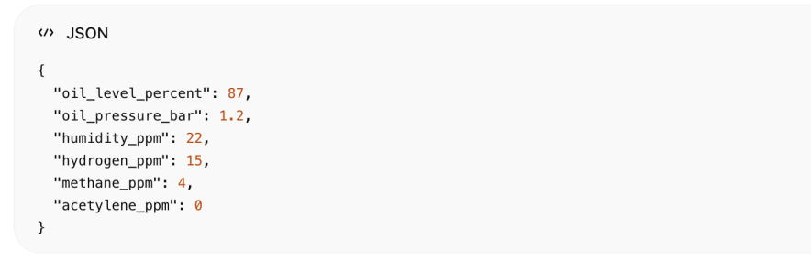

MQTT topic struktura
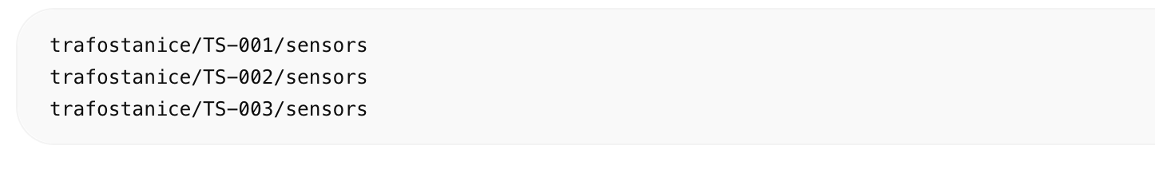
trafostanice/TS-001/sensors
trafostanice/TS-002/sensors
trafostanice/TS-003/sensors

Primjer MQTT poruke
{  "timestamp": "2026-05-16T12:00:00Z",  "station_id": "TS-001",  "geo": {  "lat": 46.3812,  "lon": 16.4321  },  "electrical": {  "voltage_kv": 10.1,  "current_a": 233,  "frequency_hz": 50.01,  "active_power_kw": 1720  },  "thermal": {  "oil_temp_c": 66,  "winding_temp_c": 74  },  "oil_gas": {  "oil_level_percent": 91,  "hydrogen_ppm": 12  }  } | 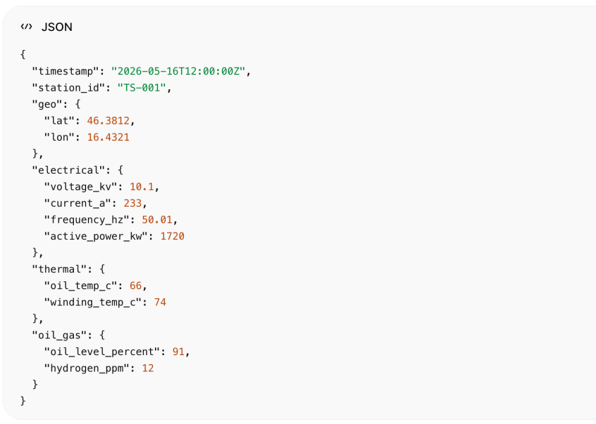

Locust simulator primjer
from locust import User, task, between  import json  import random  import time  import paho.mqtt.publish as publish  stations = [  {  "id": "TS-001",  "lat": 46.3812,  "lon": 16.4321  },  {  "id": "TS-002",  "lat": 46.3851,  "lon": 16.4358  }  ]  class TrafostanicaUser(User):  wait_time = between(1, 3)  @task  def send_sensor_data(self):  station = random.choice(stations)  payload = {  "timestamp": time.time(),  "station_id": station["id"],  "geo": {  "lat": station["lat"],  "lon": station["lon"]  },  "electrical": {  "voltage_kv": round(random.uniform(9.8, 10.5), 2),  "current_a": random.randint(150, 400),  "frequency_hz": round(random.uniform(49.8, 50.2), 2),  "active_power_kw": random.randint(1000, 3000),  "reactive_power_kvar": random.randint(100, 500),  "harmonics_thd": round(random.uniform(1.0, 5.0), 2)  },  "thermal": {  "oil_temp_c": random.randint(45, 85),  "winding_temp_c": random.randint(50, 95),  "ambient_temp_c": random.randint(-5, 35)  },  "oil_gas": {  "oil_level_percent": random.randint(70, 100),  "oil_pressure_bar": round(random.uniform(1.0, 2.0), 2),  "humidity_ppm": random.randint(5, 40),  "hydrogen_ppm": random.randint(0, 25),  "methane_ppm": random.randint(0, 10),  "acetylene_ppm": random.randint(0, 3)  }  }  publish.single(  f"trafostanice/{station['id']}/sensors",  payload=json.dumps(payload),  hostname="localhost"  ) | 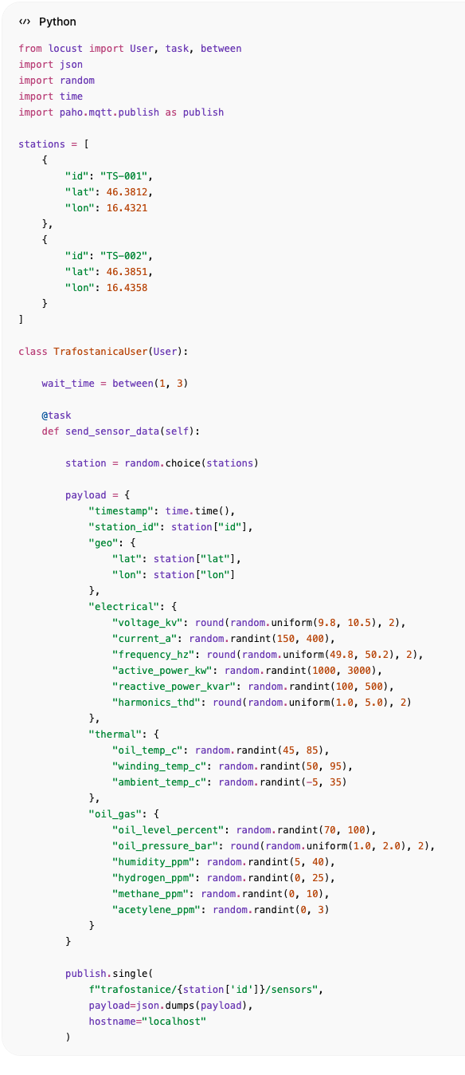

Što dalje
Sljedeći koraci su:

1. Locust simulator
- generiranje MQTT podataka

2. EMQX Rule Engine
- MQTT → CrateDB

3. FastAPI backend
- REST API
- WebSocket

4. Vue dashboard
- Leaflet mapa
- live senzori
- alarmi
- grafovi

Konačni rezultat
Dobit ćeš:
- live SCADA-like sustav
- realtime mapa Čakovca
- simulaciju trafostanica
- MQTT streaming
- CrateDB storage
- Vue dashboard
- alarm monitoring
- geolokacije trafostanica
- mogućnost skaliranja na tisuće uređaja
窗体顶端

窗体底端

